DATA ANALYTICS WITH POWER BI
PROJECT REPORT
(Project Semester August-December 2025)

Crash Data Intelligence Analysis

Submitted by
Harisvardhan Singh Naghyal

Registration No. 12319805

Programme: B.Tech CSE
Section: K23BG
Course Code: INT374

Under the Guidance of
Vikas Mangotra
UID: 31488
Assistant professor

Discipline of CSE/IT
Lovely School of Computer science and Engineering

Lovely Professional University, Phagwara

DECLARATION

I, Harisvardhan student of Computer science and Engineering under CSE/IT Discipline at, Lovely Professional University, Punjab, hereby declare that all the information furnished in this project report is based on my own intensive work and is genuine.


Date: 12-12-2025 Signature:
Registration No.: 12319805 Name of the student: Sourav

CERTIFICATE

This is to certify that Harisvardhan bearing Registration no. 12319805 has completed INT374 project titled, “Crash Data Intelligence Analysis” under my guidance and supervision. To the best of my knowledge, the present work is the result of his original development, effort and study.

Signature and Name of the Supervisor
Designation of the Supervisor
School of Computer science and Engineering
Lovely Professional University
Phagwara, Punjab.

Date: 12-12-2025

Acknowledgement

I would like to express my sincere gratitude to my faculty, Dr. Vikas Mangotra, for his continuous guidance, valuable feedback, and consistent support throughout this project.
I would also like to thank Lovely Professional University for providing the resources and academic environment that allowed me to complete this project successfully.
Last but not least, I extend my thanks to my friends for their encouragement and support during the course of this work.

Sourav

Table of Contents
- Introduction
- Source of Dataset
- Dataset Preprocessing
3.1 Handling Missing Values
3.2 Data Cleaning
3.3 Feature Engineering
3.4 Data Modeling in Power BI
- Analysis on Dataset
4.1 Overall Crash Summary
4.2 Crashes by Surface Condition
4.3 Most Common Collision Types
4.4 Crashes by Weather Condition
4.5 Crash Trend by Month
4.6 Speed Limit vs Crash Volume
4.7 Driver At-Fault Analysis
4.8 Crashes by Vehicle Make
4.9 Vehicle Damage Extent Analysis
4.10 Geographical Crash Distribution
- Conclusion
- Future Scope
- References

Introduction

In today’s rapidly growing transportation ecosystem, road safety analysis has become a critical requirement for reducing traffic accidents and improving public safety. With the increasing number of vehicles and expanding road networks, large volumes of crash-related data are generated every year. Traditional methods of analyzing such data are often time-consuming and ineffective, making it difficult to identify key risk factors and accident patterns. This challenge highlights the importance of data-driven solutions for traffic crash analysis.
The Crash Intelligence Dashboard is an interactive data analytics system developed using Microsoft Power BI to analyze, visualize, and interpret large-scale road crash data. The dashboard transforms raw crash records into meaningful insights by presenting key performance indicators (KPIs), trends, and patterns through intuitive visualizations. It enables stakeholders to understand crash frequency, injury severity, collision types, environmental conditions, driver responsibility, vehicle involvement, and geographical distribution of accidents.
This dashboard provides a comprehensive overview of road safety by integrating critical metrics such as Total Crashes, Injury Crashes, Average Speed, and Peak Crash Year. It further analyzes crashes across multiple dimensions including surface condition, weather condition, collision type, speed limit, vehicle make, driver fault, and extent of vehicle damage. Interactive filters allow users to dynamically explore data by crash year, route, lighting condition, and collision type.
By converting complex datasets into visually intelligent insights, the Crash Intelligence Dashboard supports data-driven decision-making for traffic authorities, urban planners, policymakers, and researchers. The project demonstrates the practical application of business intelligence tools in the transportation domain, highlighting how analytical dashboards can help identify high-risk conditions, improve road safety strategies, and support informed policy formulation

- Source of Dataset

The dataset used in this project was sourced from the Catalog, an open platform that provides real-world datasets for data analysis and visualization practice.

Dataset Name: Real Estate Sales 2001-2023 GL
Source Link: https://catalog.data.gov/dataset/crash-reporting-drivers-data
The dataset used for the Crash Intelligence Dashboard project was obtained from the Crash Reporting – Drivers Data repository published on Data.gov, the official open data portal of the United States government. This dataset contains detailed information about motor vehicle operators (drivers) involved in traffic collisions on county and local roadways. It is collected through the Automated Crash Reporting System (ACRS) maintained by the Maryland State Police and reported by various law enforcement agencies including the Montgomery County Police, Gaithersburg Police, Rockville Police, and the Maryland-National Capital Park Police. Data.gov

Dataset Preprocessing

Dataset preprocessing is a critical step in preparing raw crash data for accurate analysis and meaningful visualization. The crash reporting dataset obtained from Data.gov contained large volumes of real-world traffic crash records with inconsistencies, missing values, and unstructured attributes. To ensure reliable insights and smooth dashboard performance in Power BI, several preprocessing techniques were applied to clean, transform, and structure the data.
3.1 Handling Missing Values
The dataset contained missing or unknown values in several important fields related to crash and driver information. These included:
- Weather Condition
- Surface Condition
- Collision Type
- Speed Limit
- Driver At-Fault Indicator
- Vehicle Make
- Geographic Location (Latitude & Longitude)
Missing values were handled using the following approaches:
- Records with critical missing fields were flagged as “Unknown” to preserve data integrity.
- Non-essential missing values were excluded from specific visual calculations to avoid distortion.
- Blank or null entries were standardized to ensure consistent filtering and aggregation.
This approach ensured that no major crash patterns were lost while maintaining analytical accuracy.

3.2 Data Cleaning
To make the dataset consistent and analysis-ready, multiple data cleaning steps were performed:
- Removed duplicate crash records to prevent inflated crash counts.
- Standardized categorical fields such as Weather, Surface Condition, and Collision Type.
- Converted numeric attributes such as Speed Limit, Crash Count, and Injury Indicators into appropriate data types.
- Corrected inconsistent labeling in vehicle make names (e.g., merging similar brand variations).
- Ensured uniform formatting across date and time fields.
These steps significantly improved data consistency and dashboard reliability.

3.3 Feature Engineering
To enhance analytical depth and derive meaningful insights, several new features were created from the raw dataset:
- Injury Crash Indicator to distinguish injury-related crashes from non-injury crashes.
- Crash Year and Crash Month derived from crash dates to support time-based trend analysis.
- Speed Categories to analyze crash volume across different speed limits.
- Driver Fault Classification to identify responsibility patterns in crashes.
- Damage Severity Categories to evaluate vehicle impact extent.
These engineered features enabled deeper insights across driver behavior, environmental conditions, and crash severity.

3.4 Data Modeling in Power BI
For efficient reporting and interactivity, the cleaned dataset was modeled using Power BI’s data modeling capabilities:
- Established relationships between crash attributes such as Date, Route, Collision Type, and Vehicle Make.
- Created calculated measures for key KPIs including Total Crashes, Injury Crashes, Average Speed, and Peak Crash Year.
- Enabled slicers for dynamic filtering by Crash Year, Light Condition, Collision Type, and Route.
- Integrated geographic fields with map visuals to display spatial crash distribution.
This structured data model ensured smooth dashboard performance, accurate aggregations, and intuitive user interaction.

Analysis on Dataset
The Crash Intelligence Dashboard analyzes road accident data using interactive Power BI visualizations to identify key crash patterns and risk factors. This section focuses on crash frequency, environmental conditions, driver responsibility, vehicle involvement, and time-based trends. Various charts and maps are used to simplify complex crash data into meaningful insights. The analysis helps in understanding accident-prone conditions and supports data-driven road safety decisions.
4.1 Overall Market Summary
i. General Description
This analysis provides a high-level overview of road accident data using key indicators such as Total Crashes, Injury Crashes, Average Speed, and Peak Crash Year. These KPIs reflect the overall scale, severity, and trend of road crashes in the dataset and help in understanding the general road safety condition.

ii. Specific Requirements
- Measure the total number of recorded crashes.
- Identify the number of injury-related crashes.
- Analyze the average speed associated with crash occurrences.
- Determine the year with the highest number of crashes.
iii. Analysis Results
The dashboard shows:
- Total Crashes: 205K
- Injury Crashes: 74K
- Average Speed: 33
- Peak Crash Year: 2016

This indicates a high volume of road crashes with a significant proportion resulting in injuries. The average speed value suggests that crashes commonly occur within moderate speed limits, while the peak crash year highlights a period of increased accident occurrence, requiring focused road safety measures.

4.2 Crashes by Surface Condition
The visualization shows that most crashes occur on dry road surfaces, followed by wet conditions. This is mainly due to higher traffic volume under normal driving conditions. Crashes on snow, ice, oil, and sand surfaces are comparatively very low.

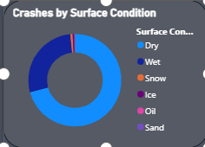

4.3 Most Common Collision Types
The dashboard shows that the majority of crashes involve rear-end and angle collisions. These types are more frequent due to high traffic density and intersection-related conflicts. Other collision types, such as sideswipe or head-on, occur less often.
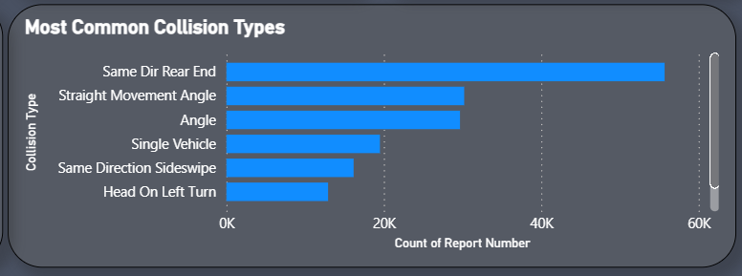

4.4 Crashes by Weather Condition
The dashboard shows that most crashes occur during clear weather, followed by rainy conditions. Adverse weather like snow, fog, or ice contributes to fewer crashes, likely due to reduced traffic or careful driving. This visualization helps identify how weather impacts accident frequency.
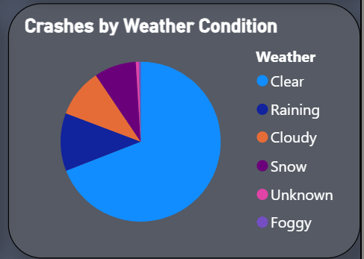

4.5 Crash Trend by Month
The line chart shows that crash frequency varies throughout the year, with peaks during months of high traffic and holidays. Lower crash counts are observed during months with reduced vehicle movement. This trend helps identify seasonal patterns in road accidents.
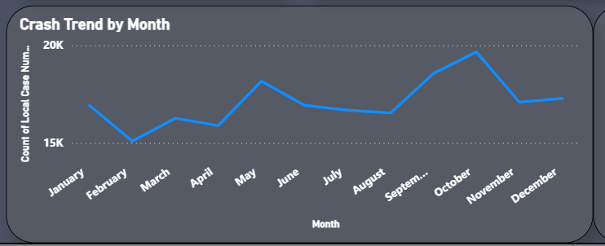

4.6 Speed Limit vs Crash Volume
The visualization shows that crashes are more frequent on roads with moderate speed limits, while very high or very low speed zones experience fewer incidents. This indicates that traffic density and driver behavior at common speed limits are major contributors to crash occurrence.
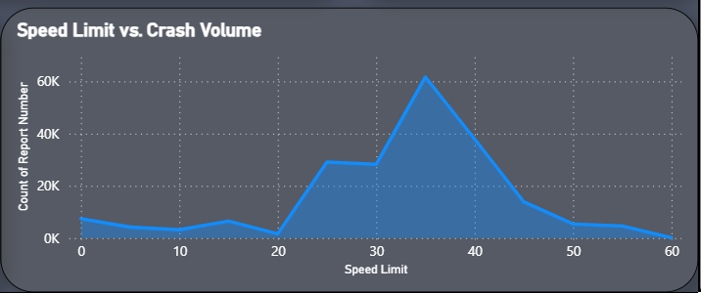
4.7 Driver At-Fault Analysis
The Driver At-Fault analysis shows that a large proportion of crashes are attributed to driver fault, indicating the significant role of human behavior in road accidents. A smaller share of crashes is marked as not at fault or unknown. This insight highlights the need for better driver awareness and safety enforcement.

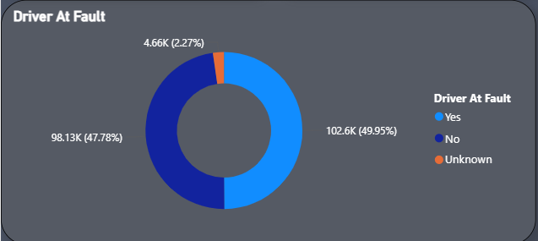

Conclusion

The Crash Intelligence Dashboard successfully transforms large-scale and complex road crash data into meaningful, interactive, and actionable business intelligence. By leveraging Power BI for advanced visual analytics, the project provides a comprehensive understanding of crash patterns, injury severity, environmental conditions, driver behavior, vehicle involvement, and geographical distribution of road accidents across multiple years and regions.
The analysis revealed several important findings:
• The crash dataset indicates a high volume of road accidents, with 205K total crashes, reflecting significant road safety challenges.
• A substantial number of crashes resulted in injuries (74K injury crashes), highlighting the serious human impact of traffic accidents.
• Analysis of surface conditions showed that dry roads account for the majority of crashes, mainly due to higher traffic exposure, followed by wet road conditions.
• Weather-based analysis revealed that most crashes occur during clear weather, while adverse conditions such as rain and fog contribute to fewer but riskier incidents.
• Collision type analysis identified rear-end and angle collisions as the most common, indicating congestion and intersection-related risks.
• Speed limit analysis showed that crashes are most frequent at moderate speed limits, suggesting that traffic density and driver behavior play a crucial role.
• Driver at-fault analysis confirmed that a large proportion of crashes are caused by driver negligence or error, emphasizing the importance of road safety awareness and enforcement.
• Time-based trend analysis highlighted 2016 as the peak crash year, indicating periods requiring focused policy and safety interventions.
• Vehicle and damage analysis revealed varying levels of impact severity, providing insights into crash consequences and vehicle safety outcomes.
Overall, the dashboard enhances road safety transparency, supports data-driven decision-making, and enables traffic authorities, policymakers, and researchers to evaluate accident patterns with clarity and confidence. It assists in identifying high-risk conditions, accident-prone scenarios, and priority areas for safety improvement.
This project demonstrates the power of data analytics and business intelligence in the transportation domain, showcasing how raw crash data can be transformed into insightful, visually intuitive dashboards that significantly support road safety planning, accident prevention strategies, and policy formulation.

Future Scope

While the Crash Intelligence Dashboard provides valuable insights into road accident patterns, crash severity, environmental conditions, and driver behavior, there are several opportunities to further enhance its analytical depth and real-world applicability. Future enhancements can significantly improve the system’s effectiveness in supporting road safety planning and accident prevention.
- Integration of Predictive Analytics
Machine learning models can be integrated to predict high-risk crash locations, future accident trends, and injury probability based on historical data. This would enable proactive safety measures rather than reactive analysis.
- Real-Time Crash Data Integration
Connecting the dashboard to live traffic surveillance systems, IoT sensors, or real-time crash reporting platforms would allow continuous monitoring of accidents and immediate response planning.
- Advanced Geospatial Analysis
Future versions may include heatmaps, accident severity zones, and road-segment-level analysis to identify accident-prone corridors and intersections with higher precision.
- Driver Behavior and Violation Analysis
By integrating datasets related to traffic violations, license history, and behavioral patterns, deeper insights into driver-related crash causes can be achieved, supporting targeted awareness and enforcement programs.
- Integration with Weather and Traffic Systems
Linking real-time weather forecasts and traffic congestion data can help predict risk conditions and issue early warnings for drivers and authorities.
- Automated Alerts and Decision Support
The dashboard can be enhanced with automated alerts and AI-driven recommendations for traffic authorities when crash thresholds or risk indicators exceed safe limits.
- Enhanced Data Quality and Expansion
Future improvements may include automated data validation, enrichment with population and road infrastructure data, and expansion to multi-state or national-level crash datasets.
Overall, these enhancements would transform the Crash Intelligence Dashboard into an intelligent, predictive, and real-time road safety decision-support system, significantly contributing to accident reduction and safer transportation planning.
.
7. References
- Crash Reporting – Drivers Data.
Data.gov.
Dataset accessed from the U.S. Government Open Data Portal for academic and analytical purposes.
Source: https://catalog.data.gov/dataset/crash-reporting-drivers-data
- Microsoft Power BI Documentation.
Microsoft Corporation.
Official documentation used for data modeling, DAX calculations, report creation, and dashboard visualization.
Source: https://learn.microsoft.com/power-bi/
- Maryland State Police – Automated Crash Reporting System (ACRS).
Dataset documentation and crash reporting methodology used as reference for understanding crash data structure and attributes.
- Traffic Safety and Accident Analysis Studies.
Publicly available research articles and reports referenced for understanding crash patterns, driver behavior, and road safety analysis concepts.
Public Link to DashBoard:

